
FREIGHT FORWARDING MEETING – 07-15-26
Chair: Nick Roe Co-Chair: Stanley Rigaud
AGENDA
Topics of Discussion:

Freight Forwarders need to be aware on IATA Direct Air Waybill Changes

• The US Air forwarders Association (AfA) is warning freight forwarders about recent IATA changes to the Direct Air Waybill (DAWB) framework, which took effect on July 1, 2026.

• The revised framework could shift contractual liability from shippers to freight forwarders.

• Under the changes, forwarders could become responsible for issues traditionally handled by shippers, including: Cargo misdeclarations, Concealed dangerous goods, & Packaging failures

• FIATA has also expressed concerns and is seeking to delay implementation.

• The AfA argues that forwarders should not be liable for cargo they do not own, pack, or control.

• The association warns the changes could create Insurance coverage issues for freight forwarders

• AfA recommends that forwarders:
- Obtain written confirmation from each airline on which contractual framework applies before tendering cargo.
- Consult insurance providers to ensure current liability policies remain adequate under the new framework.
• The AfA emphasizes that forwarder liability insurance is designed for services forwarders perform—not for assuming shipper responsibilities.

• Small and medium-sized freight forwarders are especially encouraged to carefully review their contractual and insurance arrangements before accepting shipments.

• The AfA is also concerned that airlines may implement the new framework inconsistently, creating uncertainty for forwarders working with multiple carriers.

• IATA's position is that under the DAWB:
- Freight forwarders act as agents of the shipper, not the airline.
- Airlines often lack a direct contractual relationship with the actual shipper and may not have conducted due diligence, anti-money laundering, sanctions, or embargo compliance checks.
- If an incident occurs (such as a lithium battery fire), airlines currently have limited recourse because the responsible shipper may be unknown.

US goods trade deficit hits 14-month high in May as imports surge

SOURCE: Reuters / American Journal of Transportation - Jun 29, 2026

The U.S. goods trade deficit increased significantly in May, reaching its highest level in 14 months as businesses imported more goods while exports declined. Companies accelerated imports to avoid potential shortages and higher prices caused by the recent conflict in the Middle East. As a result, economists believe that trade will likely reduce U.S. economic growth during the second quarter of the year.
The Commerce Department reported that the goods trade deficit rose 27.4% to $105.8 billion, well above economists' expectations of $85.0 billion. Imports increased by 3.6% to $313.4 billion, also the highest level in 14 months. The sharp rise in imports reflected businesses' efforts to secure products before supply chain disruptions and rising costs became more severe.
Imports increased across several major categories. Automotive vehicle imports rose by 6.3%, while consumer goods imports climbed 5.7%. Industrial supplies, including petroleum, also increased, along with food, beverages, and other goods. Capital goods imports grew modestly but were nearly 42% higher than a year earlier, highlighting the ongoing investment boom in artificial intelligence, which relies heavily on imported equipment.
Although the United States and Iran recently signed a preliminary peace agreement, easing tensions and allowing shipping through the Strait of Hormuz to recover, economists believe the trade deficit could remain high. They argue that the continued demand for imported technology and AI-related equipment will likely keep imports elevated even as supply chains improve and oil prices decline.
At the same time, U.S. goods exports fell 5.4% to $207.7 billion in May. Exports of consumer goods, industrial supplies, capital goods, and other products all declined significantly. However, exports of food, beverages, and automotive vehicles posted modest gains, helping offset some of the broader weakness in overseas sales.
Economists warned that rising imports combined with falling exports will likely reduce U.S. gross domestic product (GDP) growth in the second quarter. While strong consumer spending and AI investments continue to support economic activity, experts cautioned that the growing reliance on imported goods could weaken national income unless it is balanced by stronger growth in U.S. exports, particularly in services.

Union chief slams ‘foreign shipping companies’ ahead of contract expiration

SOURCE: Journal of Commerce - Bill Mongelluzzo - May 21, 2026

The president of the International Longshore and Warehouse Union (ILWU) “Bobby Olvera” slammed US West Coast employers as being dominated by foreign shipping companies, accusing them of caring more about the profits they send back to their headquarters than the port communities in which they operate.

The previous contract, in which the Union scored a 32% increase in wages for its members, was finalized in 2022 after work stoppages and slowdowns that resulted in a significant diversion of cargo to East and Gulf Coast ports.

“The foreign shipping lines, they should not be operating our terminals here in the United States. That should be American stevedoring companies,” Olvera told the AgTC event. “They don’t care about our ports. It’s all about profit-generating. It’s control generating.”

Olvera said the ILWU is advocating for strong West Coast ports and their customers, including agricultural importers and exporters, before the appropriate state and federal agencies regarding legislation and regulations that impact the flow of cargo. He is saying the PMA only advocate and lobby for tax incentives and tax funds for the terminals,” Olvera said.

The Pacific Maritime Association (PMA), which represents ocean carrier and terminal operator employers in negotiations with the ILWU, said

“PMA is focused each day on promoting strong and efficient West Coast ports that support the nation’s supply chain and sustain thousands of jobs at port terminals and millions of jobs throughout the US economy,” the association said in a statement Thursday.

Former shipping company executive and Journal of Commerce contributor Ted Prince noted that the phenomenon of ocean carriers dominating terminal operators in a vertically integrated operation model has been changing due to investments by private equity and infrastructure funds in ports and marine terminals.

“How do you deal with this silent force of private equity that in my mind is going to increasingly call the shots?” Prince asked Olvera during the event.
“It starts and stops with the ports, with our public port authorities,” Olvera said. “I think we fail to recognize that they’re owned by the citizens. They’re owned by the communities. The port authority has an obligation when they execute 30- and 40-year leases on the terminals to ask the right questions.”
Those “right questions” involve how to make their facilities more responsive to port users and their needs for sufficient gate hours and efficient operations, he added.

California jury holds 3 trucking firms liable for $52M in verdict over a single crash

• A Los Angeles Superior Court jury awarded $52.1 million to motorcyclist Chad Perrigo and his wife after a 2021 crash in California.

• The crash involved Jorge Castaneda Rodriguez, an independent owner-operator who was violating federal hours-of-service (HOS) rules at the time of the collision.

• The load passed through multiple companies:
- U.S. Postal Service contracted Thunder Ridge Transport.
- Thunder Ridge subcontracted the work to Fames Transport.
- Fames subcontracted it to Montecristo Trucking.
• Although none of the upstream companies were driving the truck, three carriers were held liable under California's vicarious liability doctrine.

• California law treats motor carrier safety duties as nondelegable, meaning companies cannot avoid liability simply by subcontracting work.

• The jury found Fames Transport particularly responsible because the driver was functioning effectively as a Fames employee under California law.

• The ruling builds on the earlier Montgomery v. Caribe Transport II decision, which expanded potential liability for freight brokers.

• Legal experts say the verdict signals that any company involved in a load—especially those that subcontract it—may face significant liability for crashes.

• Attorneys advise motor carriers to properly structure, document, and manage independent contractor relationships to reduce legal risk.

• The plaintiffs' attorney believes the full $52.1 million judgment is collectible.

Containership Fire Breaks Out Every 17 Days as Mis-declared Cargo Remains a Major Threat

Container ship fires remain a serious and growing global safety issue. Allianz recorded more than 200 vessel fires in 2025, making it the second-highest annual total in the last decade. A major cause of these incidents is misdeclared or undeclared dangerous cargo, particularly lithium-ion batteries and chemicals, which account for about 25% of cargo-related incidents.
Improper cargo declarations can result in hazardous goods being stowed in unsuitable locations on board, increasing the likelihood of fires and making emergency response and firefighting efforts much more difficult. The rapid growth in lithium-ion battery shipments has further heightened the risk, with battery deployment in 2025 reaching six times the level of five years ago and expected to double again by 2030. While these batteries are essential for electric vehicles and the energy transition, damaged or improperly packaged batteries have been linked to several major shipboard fires.
The report also notes that the increasing size of modern container ships has made fire incidents more challenging to manage. Fires on mega-ships can quickly overwhelm onboard crews, sometimes forcing them to abandon the vessel before salvage teams arrive. These incidents often lead to costly general average claims, where cargo owners and shipowners share the expenses of saving the voyage, with cargo owners sometimes contributing up to 50% of the cargo's value. Vehicle carriers are also facing elevated risks, with fires occurring approximately every 37 days worldwide.
To combat the problem, the World Shipping Council has expanded its AI-powered Cargo Safety Program, which screens container bookings to identify potentially misdeclared dangerous goods before they are loaded. The system has already prevented thousands of hazardous shipments from entering the supply chain, including one case where a shipment labeled as "hand tools" was found to contain lithium-ion battery-powered equipment requiring special handling. Allianz concludes that as lithium-ion battery use continues to grow, improvements in safety standards, vessel design, and regulatory oversight will be essential to reducing the industry's fire risk.

Liner networks shift away from Asia’s mega hubs

• Container shipping networks are shifting away from the traditional hub-and-spoke model toward a more decentralized system using smaller regional ports.

• What started as temporary adjustments during the Red Sea crisis has become a long-term strategy.

• Major transshipment hubs are losing connectivity, including:
- Singapore: declined from 1,876.95 (Q4 2025) to 1,833.94 (Q2 2026).
- Port Klang (Malaysia): down 5% from its recent peak.
- Tanjung Pelepas (Malaysia): down more than 7%.
- Shanghai and Ningbo (China): both recorded quarter-on-quarter declines.
• Carriers are increasingly routing cargo through secondary ports closer to manufacturing centers instead of relying on mega-hubs.

• Ports benefiting from the shift include:
- Haiphong (Vietnam):
  - Connectivity increased to 690.29 in Q2 2026.
  - Grew 5.1% quarter-on-quarter.
  - Benefiting from China+1 manufacturing strategies and integration with southern China.
- Laem Chabang (Thailand).
- Pipavav, Ennore, and Visakhapatnam (India).
- Djibouti (East Africa).
• Middle Eastern ports are also seeing changes:
- Jeddah: connectivity increased 14.9% quarter-on-quarter.
- Khor Fakkan: connectivity surged 189%.
- Fujairah: re-entered the connectivity rankings as an alternative relay port.
• Sea-Intelligence believes this is a permanent network recalibration, not just a response to geopolitical disruptions.

• Overall trend: The industry is moving away from maximizing economies of scale through a few giant hubs and toward a more distributed network that prioritizes resilience, flexibility, and proximity to manufacturing.

What is driving the future of the shipping containers market
1. Growing Global Demand for Shipping Containers
The global shipping container market continues to expand due to rising international trade, e-commerce growth, and modernization of logistics infrastructure. Investments in ports and transportation networks are improving cargo movement and supply chain efficiency.
- Increasing international commerce and import-export activities drive demand.
- Governments and private companies are investing in ports and multimodal transport hubs.
- Automation and digital logistics are improving cargo handling and supply chain performance.

2. Artificial Intelligence Improves Logistics Operations
Artificial intelligence is transforming container logistics by enhancing operational efficiency, reducing costs, and improving cargo monitoring. AI technologies enable smarter planning, predictive maintenance, and better resource utilization.
- AI-powered sensors monitor cargo conditions in real time.
- Machine learning optimizes container usage, routing, and estimated arrival times (ETA).
- Predictive maintenance reduces downtime and operating costs. AI supports lower carbon emissions through fuel-efficient vessel routing.

3. Sustainability Drives Innovation
Sustainability creates new opportunities in container manufacturing and reuse. Companies are adopting eco-friendly materials and designs while promoting circular economy practices through recycling and repurposing containers.
- Manufacturers are introducing lightweight and energy-efficient container designs.
- Used containers are repurposed for housing, storage, commercial spaces, and infrastructure projects.
- Bamboo flooring is emerging as a durable, sustainable, and cost-effective alternative to hardwood.

4. Market Trends and Container Types
ISO-standard containers remain the dominant choice because of their compatibility with global transportation systems. However, demand for specialized containers is growing as industries require customized logistics solutions.
- ISO containers hold the largest market share.
- Specialized containers are gaining demand for oversized, refrigerated, and hazardous cargo.
- 40 ft Dry containers remain the most widely used and lead the market.
- Reefer containers are expected to experience the fastest growth due to expanding cold chain, pharmaceutical, and food transportation.

5. Asia Pacific Leads Global Production
Asia Pacific remains the world's leading shipping container manufacturing region, supported by strong exports and investments in infrastructure. Other regions are also expanding logistics capabilities to support growing trade.
- Asia Pacific accounts for about 50% of the global market.
- China dominates global container production and benefits from the Belt and Road Initiative.
- India, Japan, and South Korea are expanding regional trade and shipping capacity.
- Europe is expected to grow through advanced logistics infrastructure.
- North America benefits from e-commerce growth & port modernization.

6. Emerging Business Models Reshape the Industry
New digital business models are making container logistics more flexible and cost-effective. Technology-driven services are improving fleet management, supply chain visibility, and access to container leasing.
- Digital container marketplaces improve container availability.
- Container-as-a-Service offers flexible leasing options. These innovations are expected to transform container ownership and logistics operations in the coming years.


Upcoming Events:

49 CFR Webinar Series: Markings - July 22th
July 16, 2026
12:00 PM - 1:00 PM
FCBF, in partnership with Nova Southeastern University (NSU), is pleased to offer a free 49 CFR webinar series designed to help transportation and logistics professionals stay current with hazardous materials regulations. This webinar will focus on hazardous materials markings, covering package marking requirements, international labeling considerations, and key compliance obligations under 49 CFR.

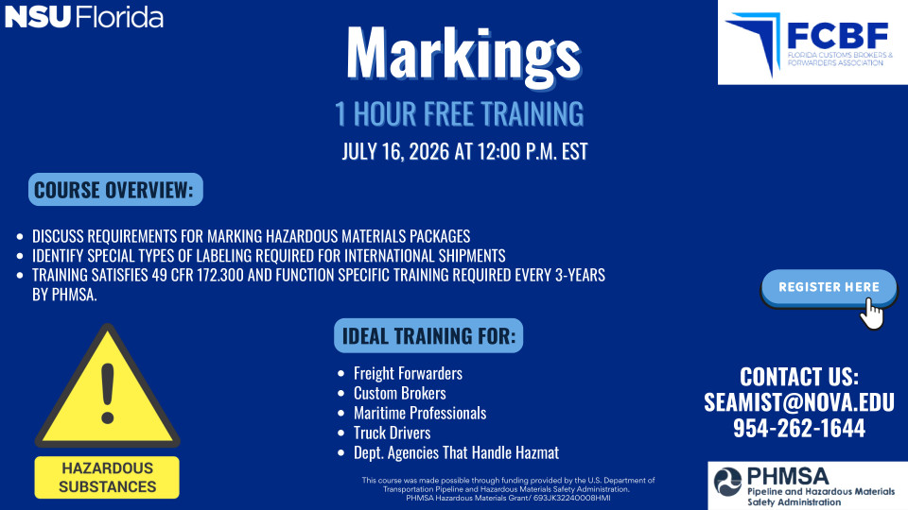

49 CFR Webinar Series: Placarding Fundamentals - July 31st

July 31, 2026
12:00 PM - 1:00 PM
Share
This webinar will provide an overview of placarding requirements and compliance considerations for hazardous materials transportation. Participants may register for the date that best fits their schedule:



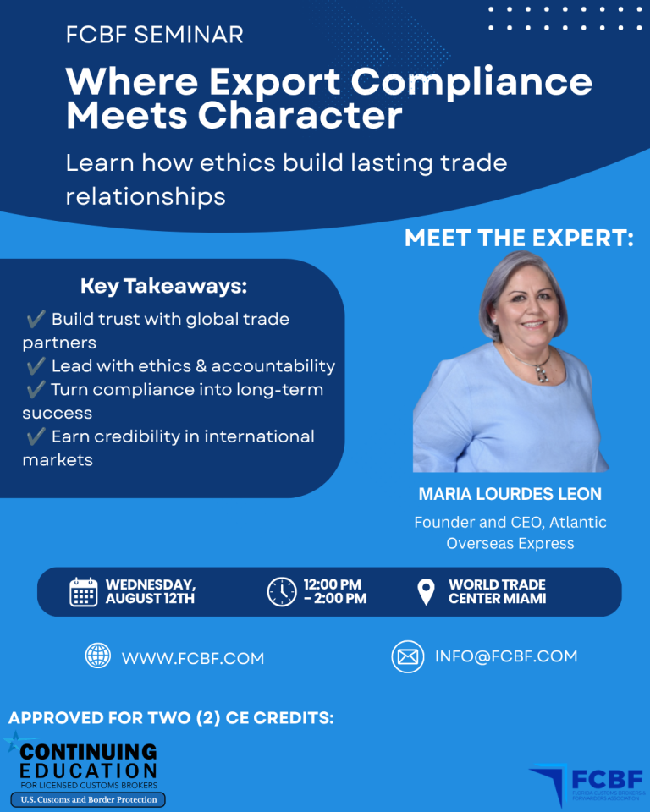

CBLE Fall 2026
August 25, 2026
6:30 PM to 9:30 PM
Miami-Dade College West Campus
3800 NW 115th Ave, Room 1009
Miami, FL 33178

FCBF, in partnership with Miami Dade College, offers an in-person CBLE course designed to help you confidently prepare for and pass the Customs Broker License Exam.




